Appendix 2- Site Photographs – Feilden Grove

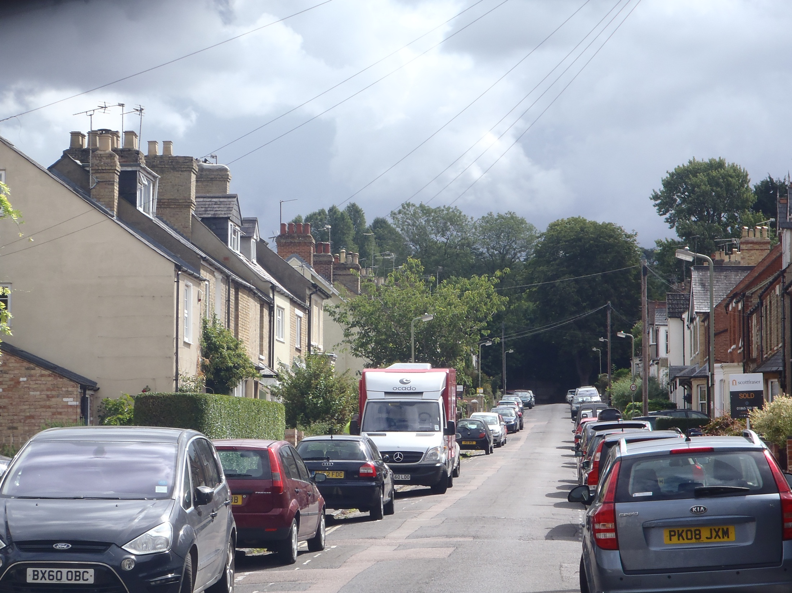
T1
Photo 1: View looking east up William Street (far view).

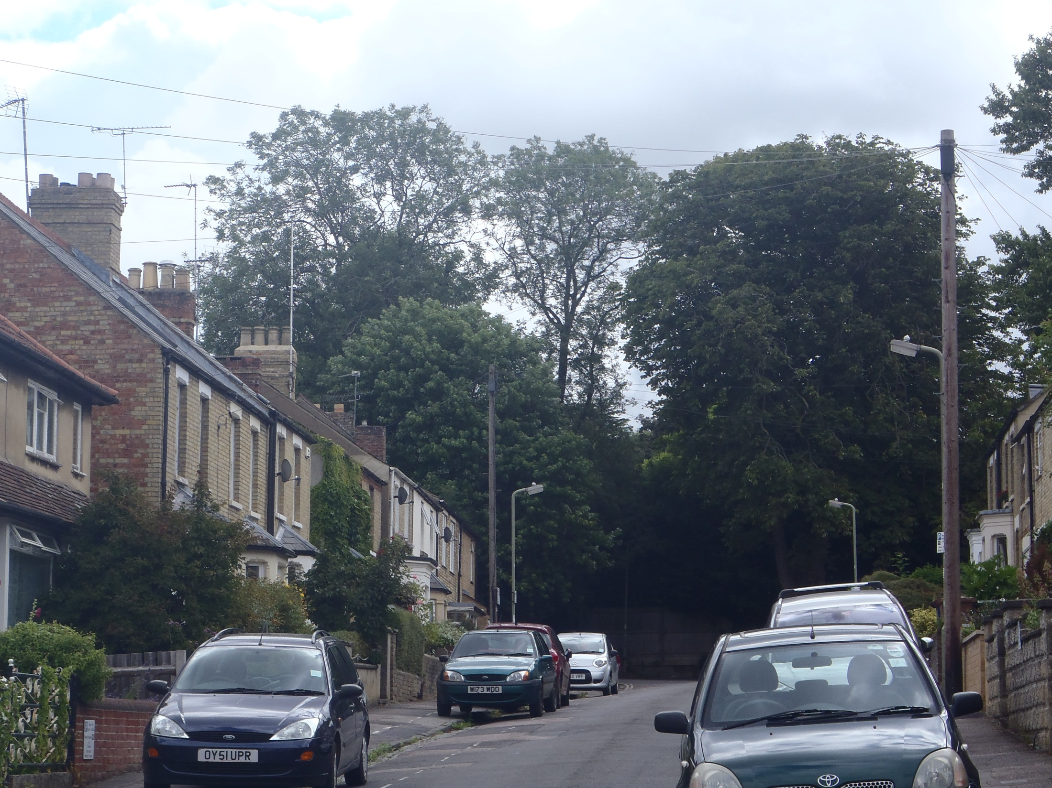
T1

Photo 2: View looking east up William Street (near view).

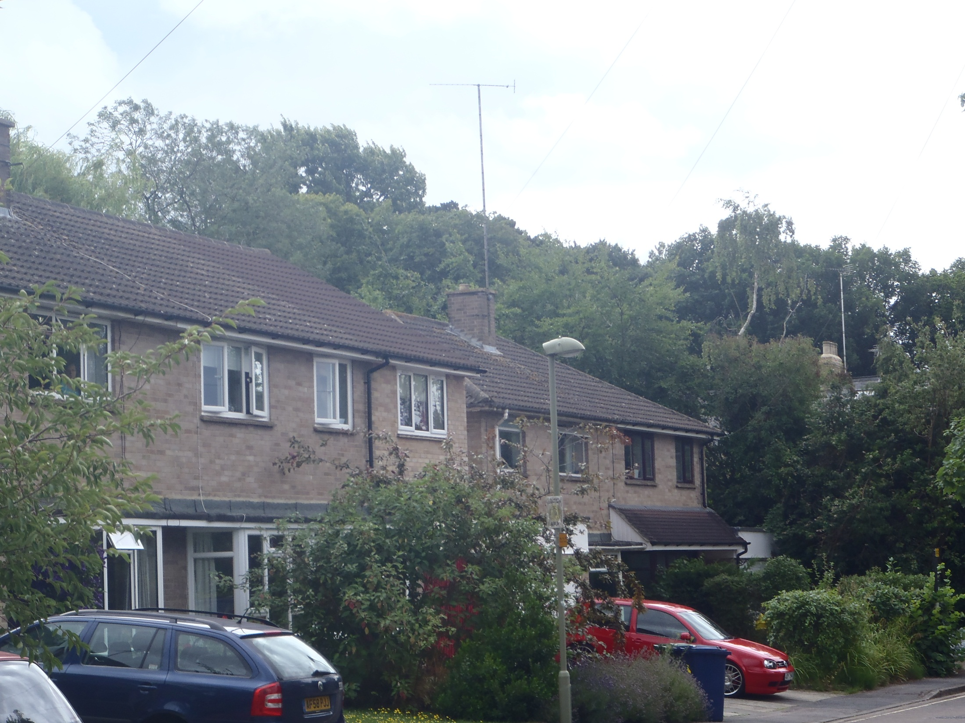
T1

Photo 3: View looking south east along Prichard Road.

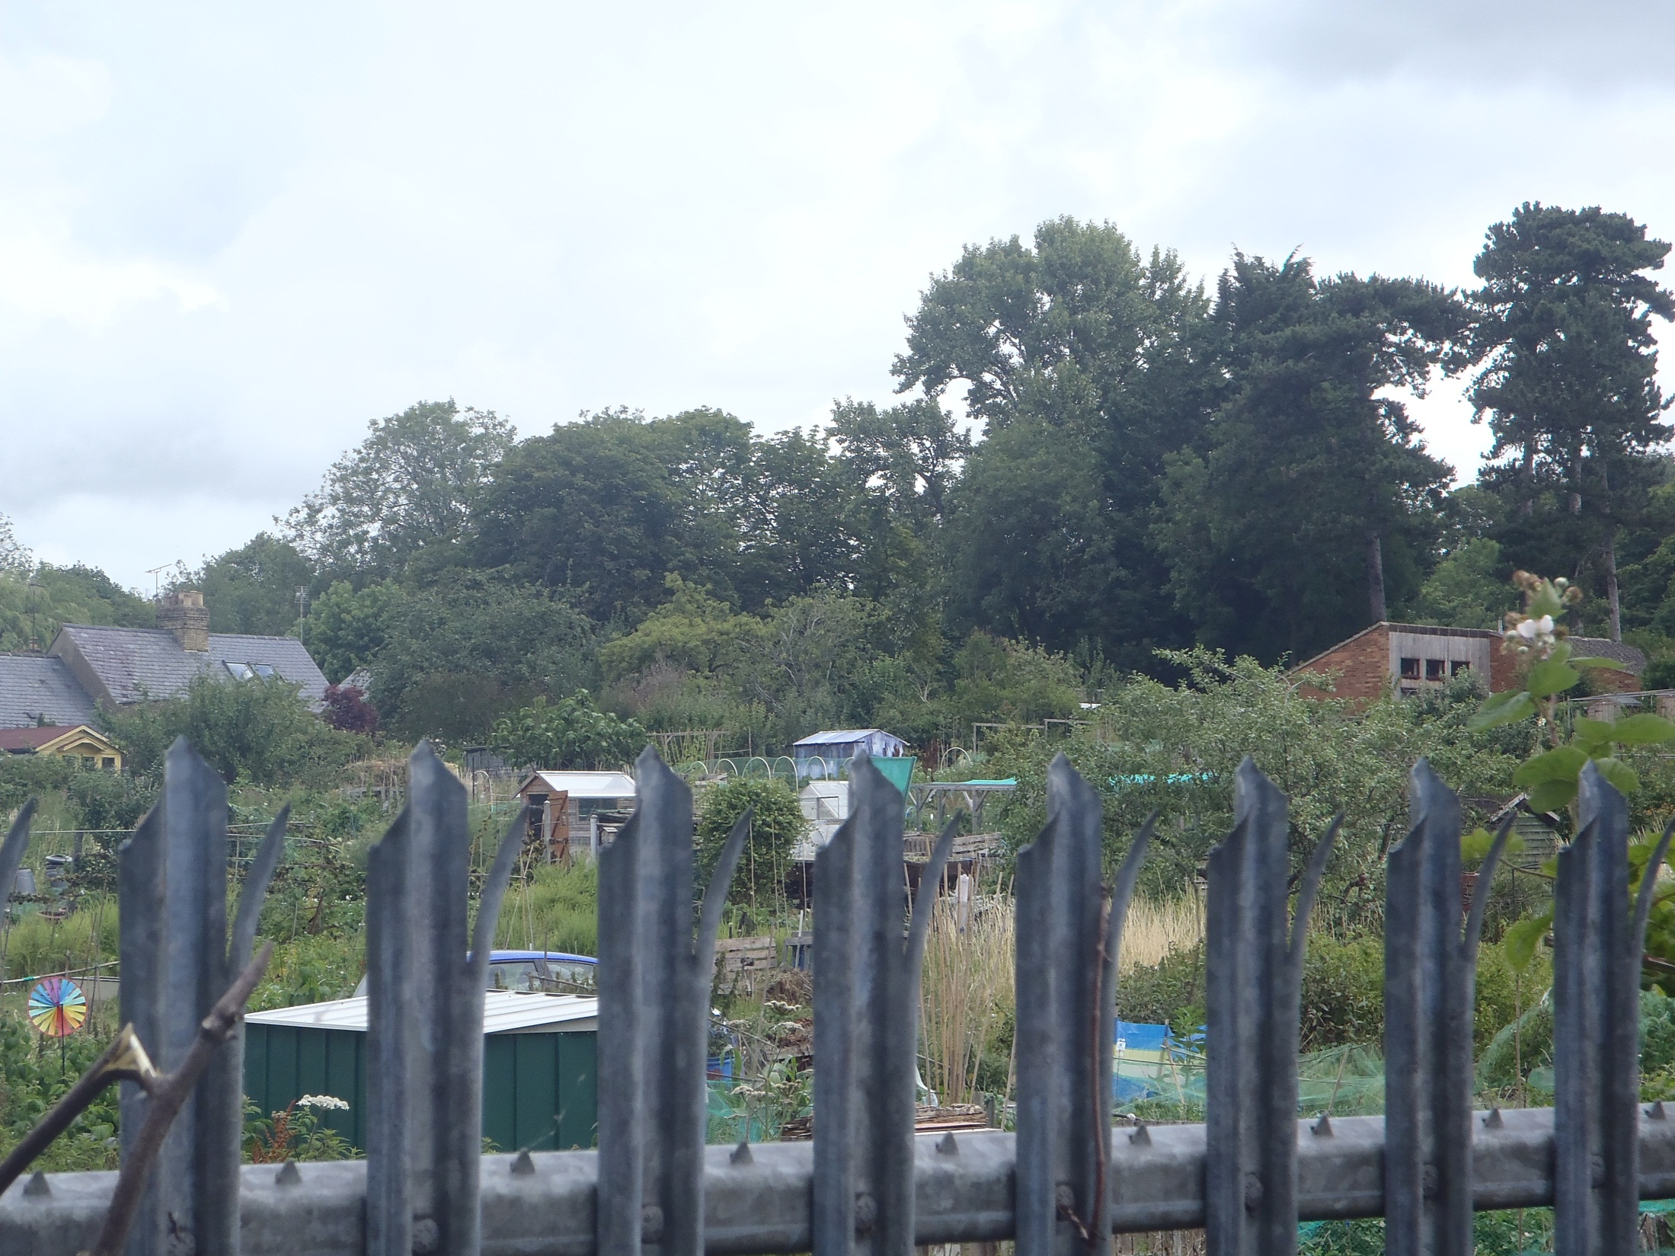
T1

Photo 4: View looking north east from Garne Way.

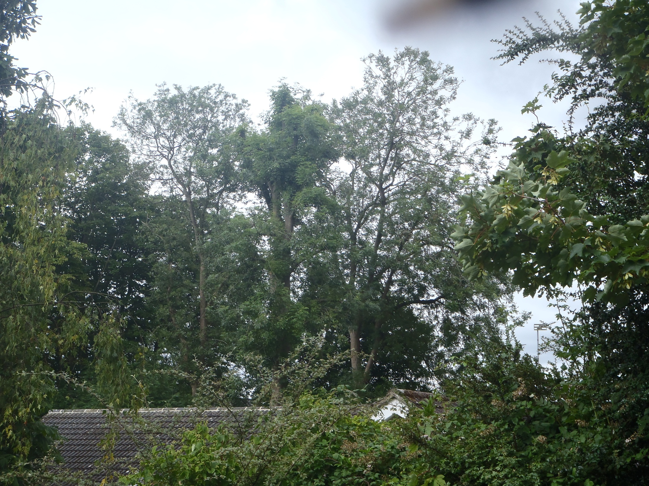
Ta
T1

Photo 5: View looking west over No 6 from Fielden Grove

